Asana Toolkit for Salesforce

Create a toolkit in Salesforce.com that manages task in Asana

By: Cloud Challenger

19th July 2012

Table of Contents

Introduction 3

Steps to Configure 3

How to use this application 3

# Introduction

Create a toolkit in Salesforce.com that manages task in Asana.

# Steps to Configure

1. To install the application on the target organization use the URL of unmanaged package as submitted along with the challenge
2. Or administrator can also use ant scrip to deploy the code on target org. The build.xml and build.properties file is submitted in the eclipse project zip file attached in the submission.

**Configuring build.properties file**

* 1. Edit the build.properties files in any editor.
  2. Add the user name and password of the target organization in the xml part as shown below

sf.username = <User name here>

sf.password = <Password Here>

* 1. After the build.properties file is configured admin can used ant to deploy the code in any target organization.

1. Add the tab “**Asana Task**” to any of the Application wherever user wants to use this functionality

# How to use this application

1. Once the application is installed using the unmanaged package URL or eclipse code deployment add the tab “**Asana Task**” to any application so the tab is generally available to user who needs to use the functionality.
2. Add Asana API Key custom field on user page layout.
3. Add the asana API key to the user for this go to Setup🡪My Personal Information🡪 Personal Information 🡪 Edit

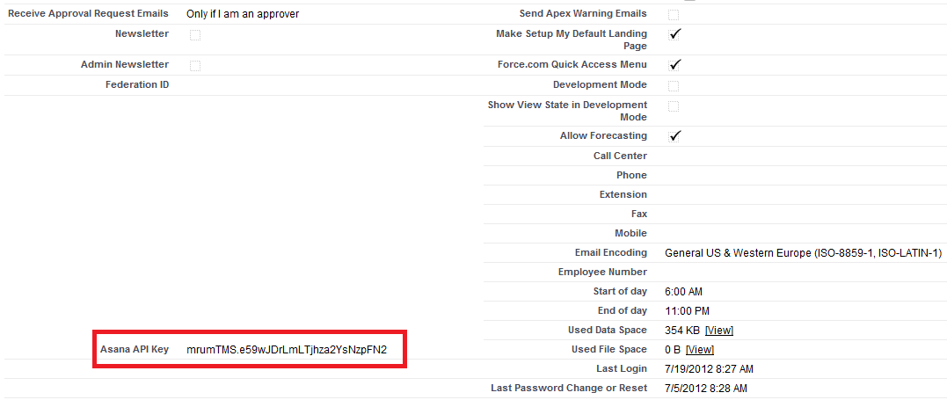

1. Save the API key for all the user who needs to use this information user can add by themselves or admin can go all user record and add the Asana API key for them
2. Click on the tab to open the VF page that allows creating tasks. The Home page is as shown below

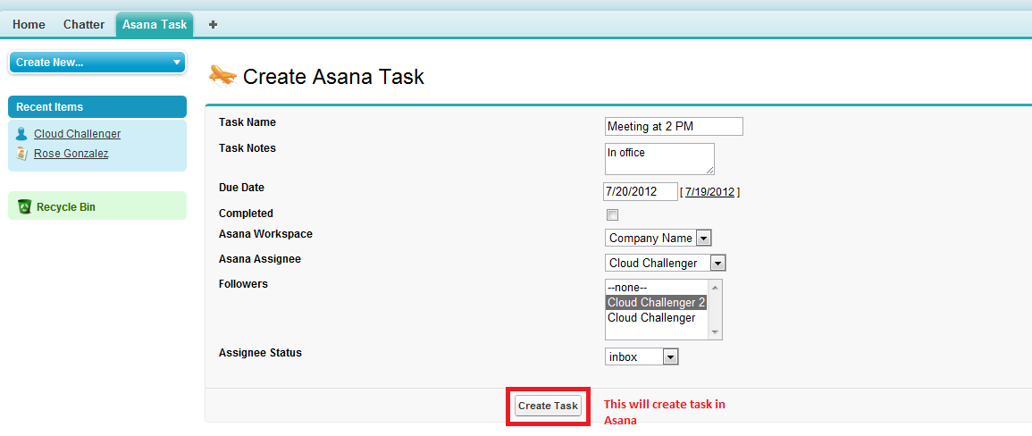

1. Fill in all the details related to task.
2. Workspaces available for the logged In user is shown in Asana Workspace select option
3. Click on the Create Task button to create a task with all the details filled in by user